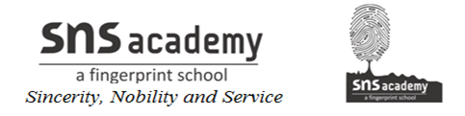
ANNUAL PLAN-2019-2020
GRADE: XII A&B SUBJECT: ENGLISH
MONTH | UNIT/TOPIC
FEBRUARY | FLAMINGO:The Last Lesson(prose)  WRITING :Note-making
MARCH | FLAMINGO: Lost Spring (prose)  My Mother at Sixty Six(poem)  WRITING : Reading comprehension,
APRIL | FLAMINGO: Deep Water (prose)  VISTAS : Third level  WRITING : Advertisement (Situation vacant/Tolet) .
MAY | FLAMINGO : The Rattrap (prose)  An Elementary School Classroom(poem)  VISTAS : The Tiger King  WRITING : . Advertisement (Sale and Purchase)
JUNE | FLAMINGO : Indigo (prose)  Keeping quiet (poem)  VISTAS : Journey at the end of the earth  WRITING : Poster designing,Notice, Invitations &  replies
JULY | FLAMINGO :Poets and Pancakes  A Thing Of Beauty (poem)  VISTAS : Journey at the end of the earth  WRITING : Business letters, Official letters
AUGUST | FLAMINGO : The Interview Part – 1  A Roadside Stand (poem)  VISTAS : Should Wizard hit Mommy  WRITING : Letters to the Editor, Job Application
SEPTEMBER | TERM – I ASSESSMENT
OCTOBER | FLAMINGO : The Interview Part – 1I  VISTAS : On the Face of it.  Evans Tries an O-Level  WRITING : Article , Speech writing
NOVEMBER | FLAMINGO : Going Places  Aunt Jennifers Tigers (poem)  VISTAS : Memories of childhood  WRITING : Debate writing
DECEMBER - FEBRUARY | Revision, Remedial teaching and Tests.

Sub. Teacher Principal

